***Taxing Sugar-sweetened Beverages***

**Introduction**

In today’s society, children are put at greater risk of developing childhood obesity and the prevalence keeps growing. The prevalence of obesity was 19.3% and affected about 14.4 million children and adolescents (1). Children that are overweight and obese have a higher risk of developing serious health problems including type 2 diabetes, high blood pressure, asthma and other respiratory problems (2). Just as childhood obesity increased, so has the consumption of sugar-sweetened beverages (SSBs). These beverages contain sugars such as sucrose and fructose in large amounts that contribute to the overall energy density of diets (2). SSBs don’t have much nutritional value and they can’t provide the same feeling of fullness that solid food can (2).

That is why a sugar-sweetened beverage tax was proposed to decrease the sales of sugary drinks. The revenue that is produced from the tax will go towards health promotion, wellness programs, etc. The tax serves the purpose of helping to improve the livelihood of low-income residents and those most affected by the health issues sugary drinks cause. This tax is not nationwide, and some states have not been able to pass the tax. However, there is progress that is being made in order to make these necessary changes for a healthier future.

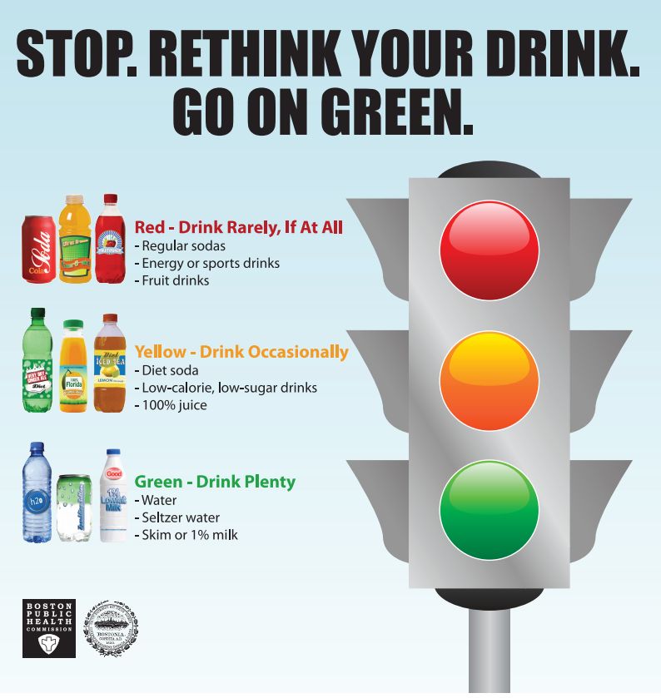

**Summary**

In an analysis of NHANES data from 2007 to 2010, 62% of preschool children ages 2–5 years consumed SSBs daily compared with 73% of children ages 6–11 years and 76% of adolescents ages 12–19 years (3). But not everyone agrees with the tax with some claiming, “Anything is harmful when consumed in excess even water can kill you if you drink too much of it. While obesity is harmful, and everyone knows it. It is not the governments place to tell me how to live my life if I'm not infringing on other rights or breaking a criminal law” (4). Despite these setbacks, the general public seems to be in favor of the SSB tax. In a recent poll in Hawaii, two-thirds of residents polled were supportive of an SSB fee to fund programs aimed at decreasing childhood obesity (4).

**Recommendations**

The following recommendations should be considered to help reduce the consumption of sugar-sweetened beverages:

* Pass a sugar-sweetened beverage tax in every state
* Limiting sugar-sweetened beverages to almost none every week
* Educating the community about sugar-sweetened beverages
* Promoting healthier drink alternatives
* Always having water as the first choice of drink advertised

**Conclusion**

A sugar-sweetened beverage tax is crucial to continue the efforts towards a healthier lifestyle. Having a tax placed on sugar-sweetened beverages makes sense because it will help produce income for health programs trying to decrease childhood obesity. By following these recommendations, a change can be made early on and will teach students along with their parents that it is important to watch what they drink and how much they drink.

References

1. Childhood obesity facts | overweight & obesity | cdc. Published April 5, 2021. Accessed July 26, 2021. <https://www.cdc.gov/obesity/data/childhood.html>

2. WHO | Reducing consumption of sugar-sweetened beverages to reduce the risk of childhood overweight and obesity. WHO. Accessed July 26, 2021. <http://www.who.int/elena/titles/ssbs_childhood_obesity/en/>

3. Scharf RJ, DeBoer MD. Sugar-sweetened beverages and children’s health. *Annu Rev Public Health*. 2016;37(1):273-293. doi:10.1146/annurev-publhealth-032315-021528

4. Bleich SN, Lawman HG, LeVasseur MT, et al. The association of a sweetened beverage tax with changes in beverage prices and purchases at independent stores. *Health Affairs*. 2020;39(7):1130-1139. doi:10.1377/hlthaff.2019.01058

5. Boston 677 Huntington Avenue, Ma 02115 +1495‑1000. Public health concerns: sugary drinks. The Nutrition Source. Published September 4, 2013. Accessed August 9, 2021. <https://www.hsph.harvard.edu/nutritionsource/healthy-drinks/beverages-public-health-concerns/>